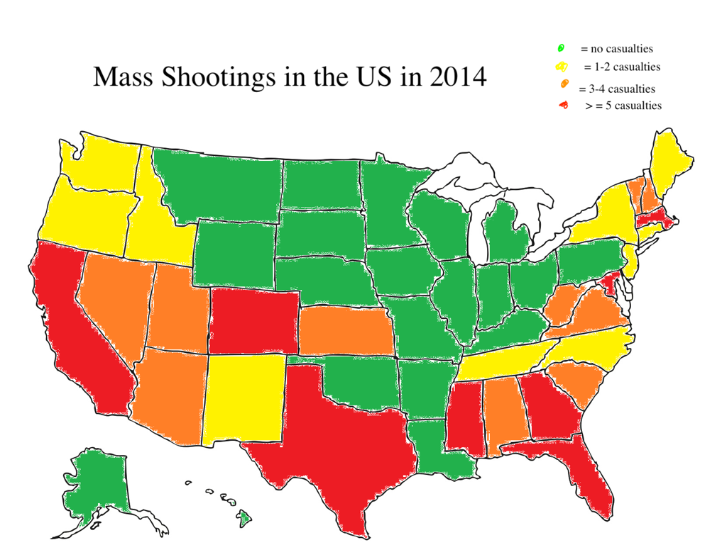 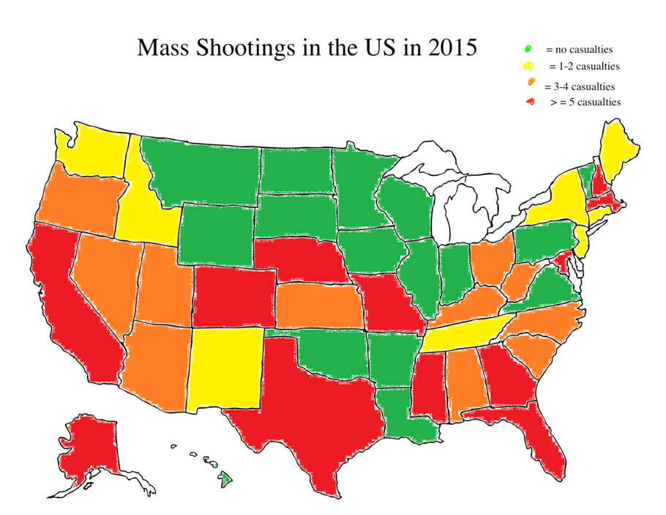

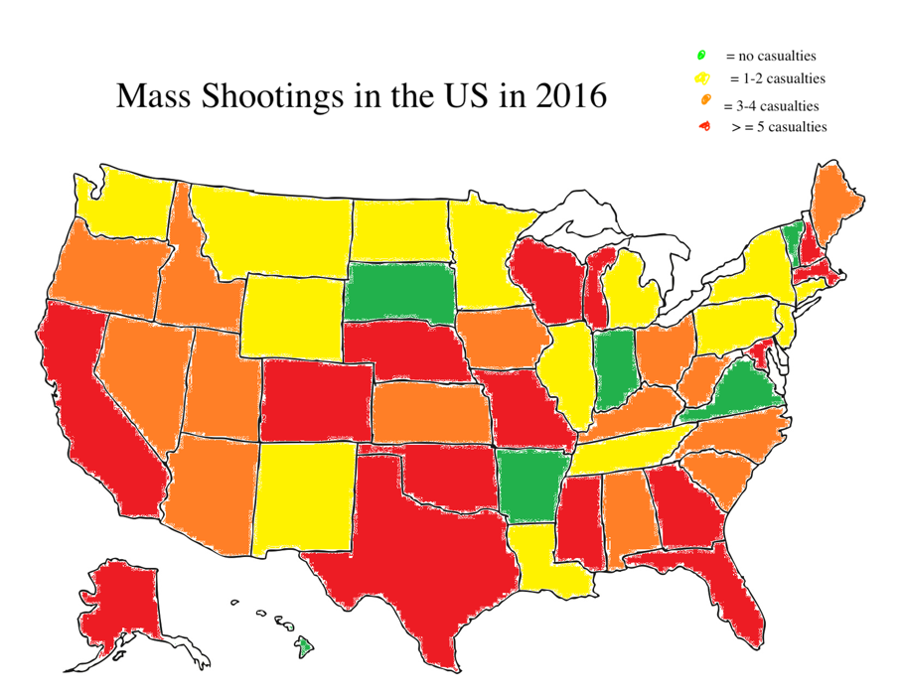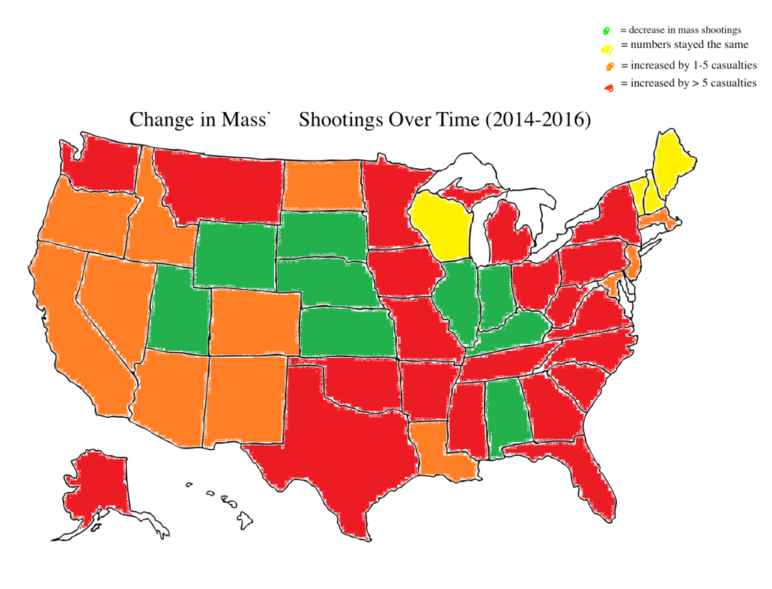

To show the change in mass shootings over time, I will have 3 maps for each of the three years, color-coded by the number of casualties for each state. I would then have a final map summarizing the change of mass shootings over time for those three years. That way, we can see the summary of the change and exactly how it occurred over time.

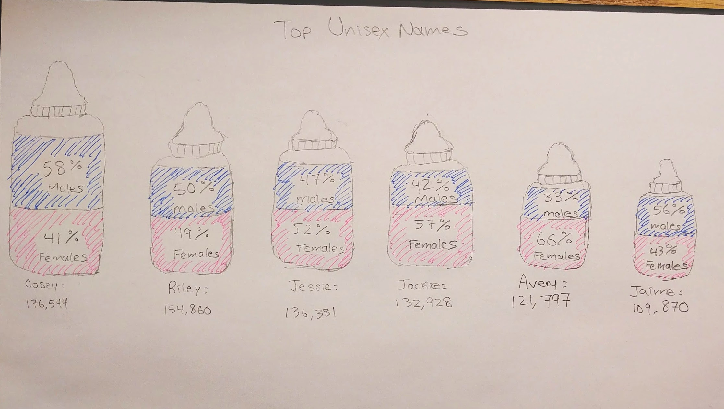

For the top unisex names, I would use baby bottles to visualize the frequency. The size of each baby bottle is proportional to the frequency of the particular name. Inside each bottle, the amount filled shows the relative frequency distribution of the name amongst the two genders. Blue will be used to help visualize the male distribution and pink for the female distribution.

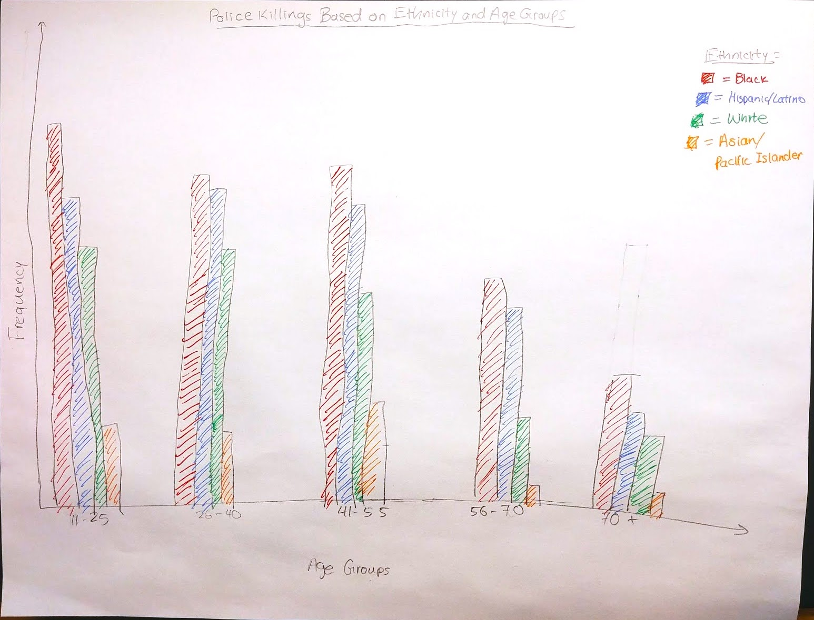

This comparative bar chart will be ordered by age groups first. Then within each age group, it will be further broken down by ethnicity. Color will be used to distinguish between the different ethnicities. We will also change the scale depending on how it fits on the webpage.